# **Over-View of Data Visualization**

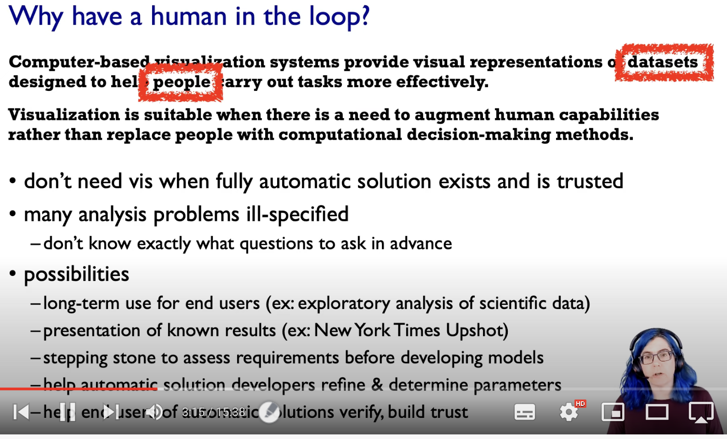

To replace cognitive acts with perceptual acts, in-order to free up the cognition for more interesting typically higher level questions than the really lower level ones.

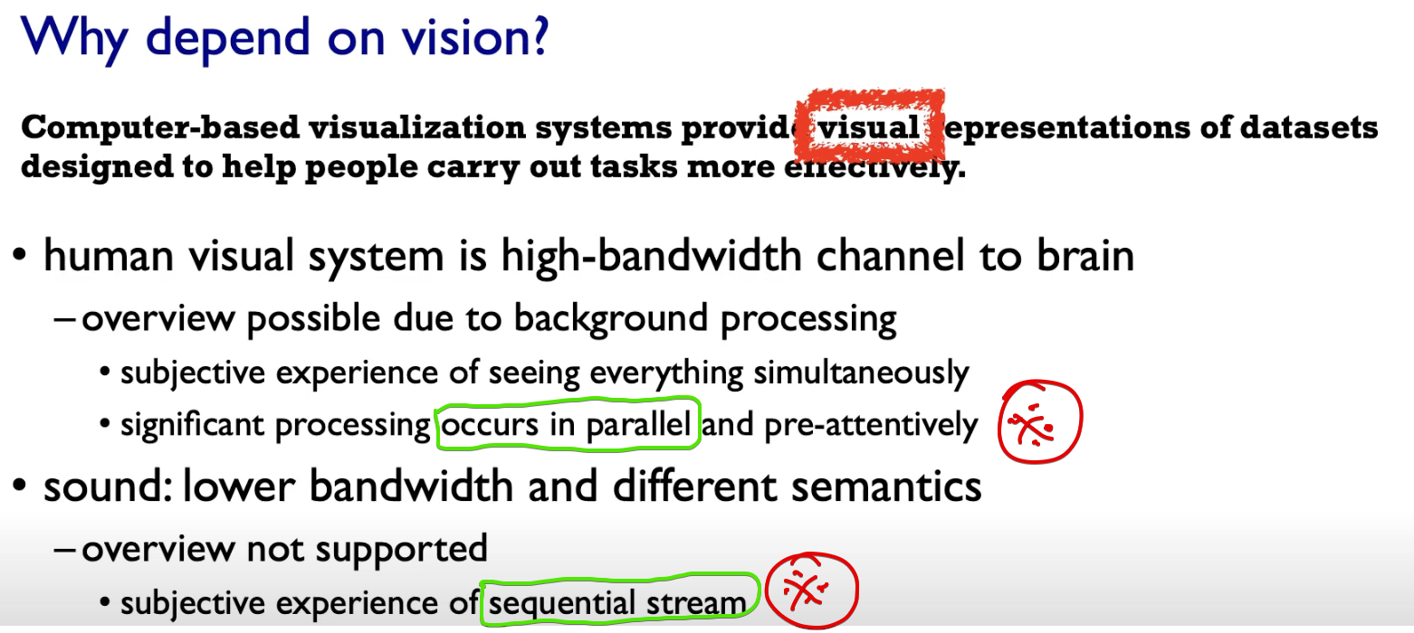

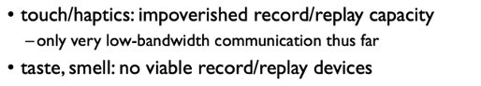

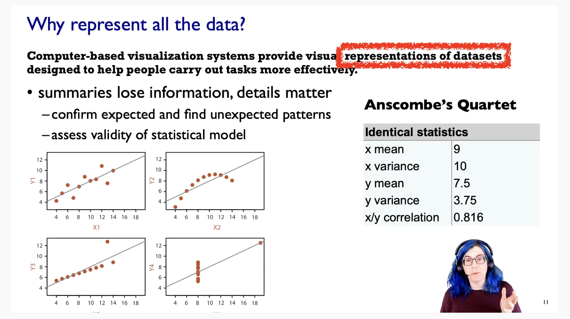

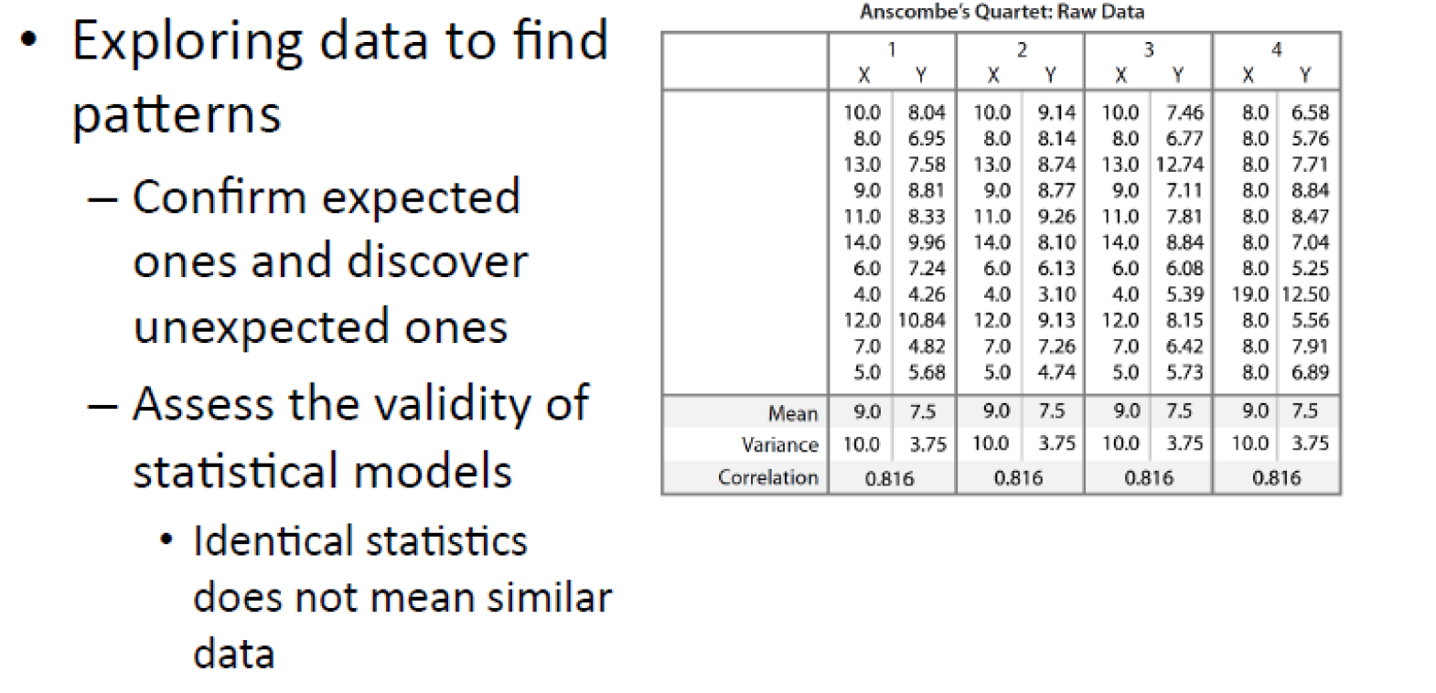

Though the mean, variance of X and Y ; Correlation of 1,2,3,4 🡪 same  
On visualization, there was a greater change in the visualization.

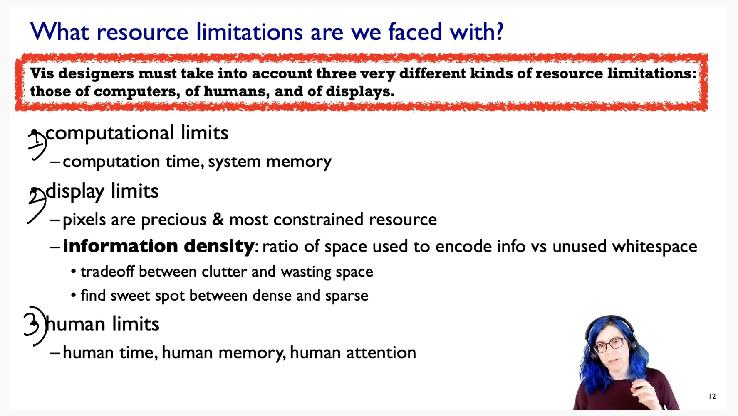

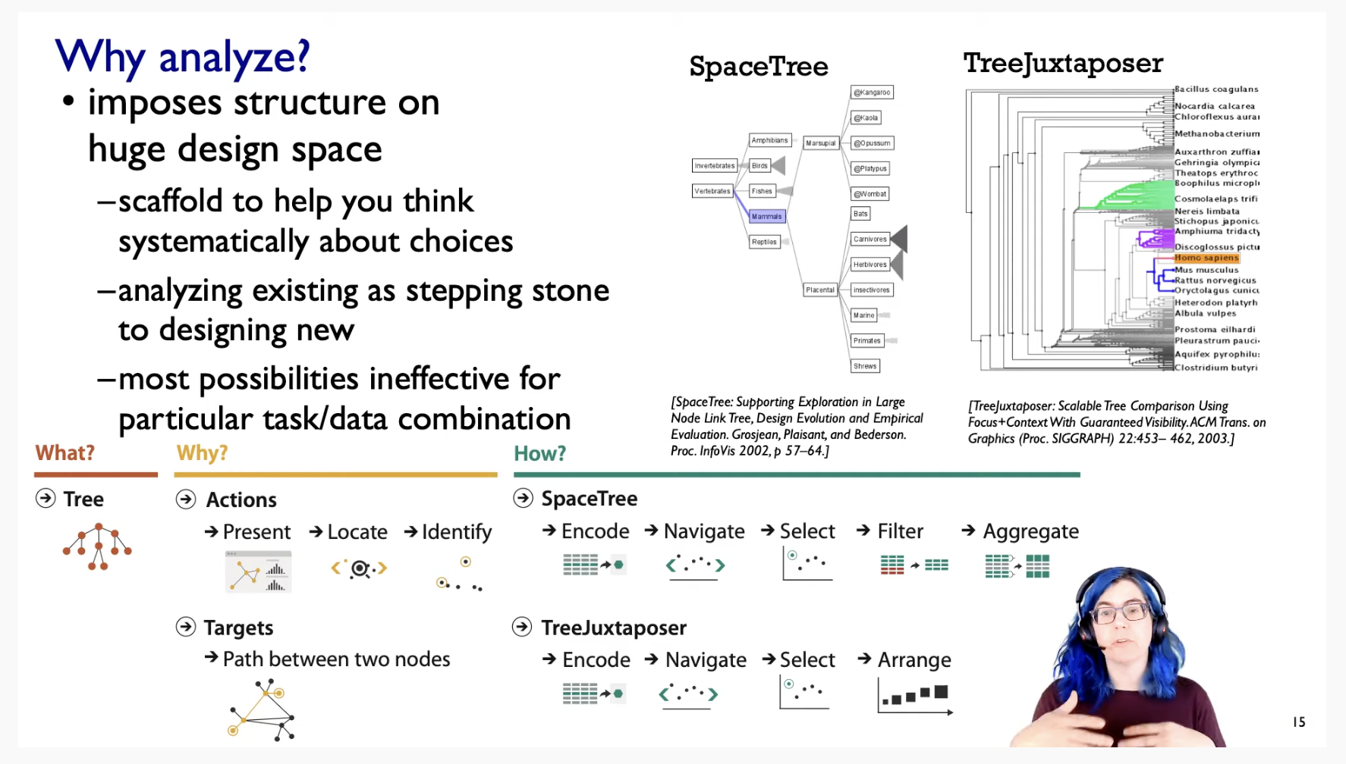

# **Data Abstraction**

These trees of ancestral relationships between species.  
Our aim is to find the leaf node from the root node.

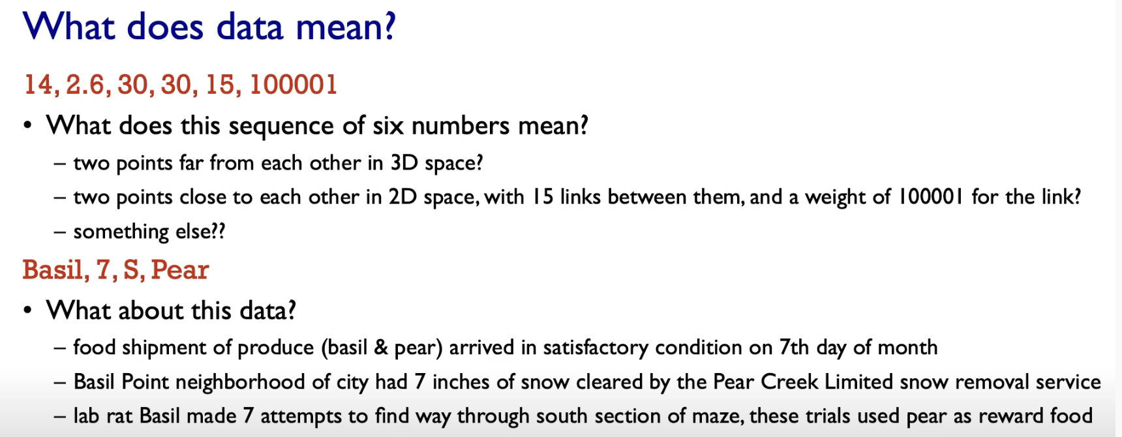

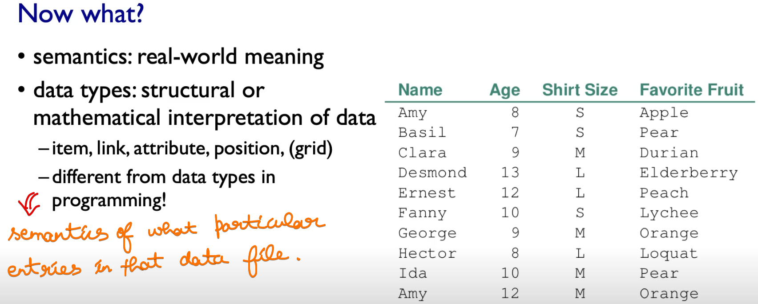

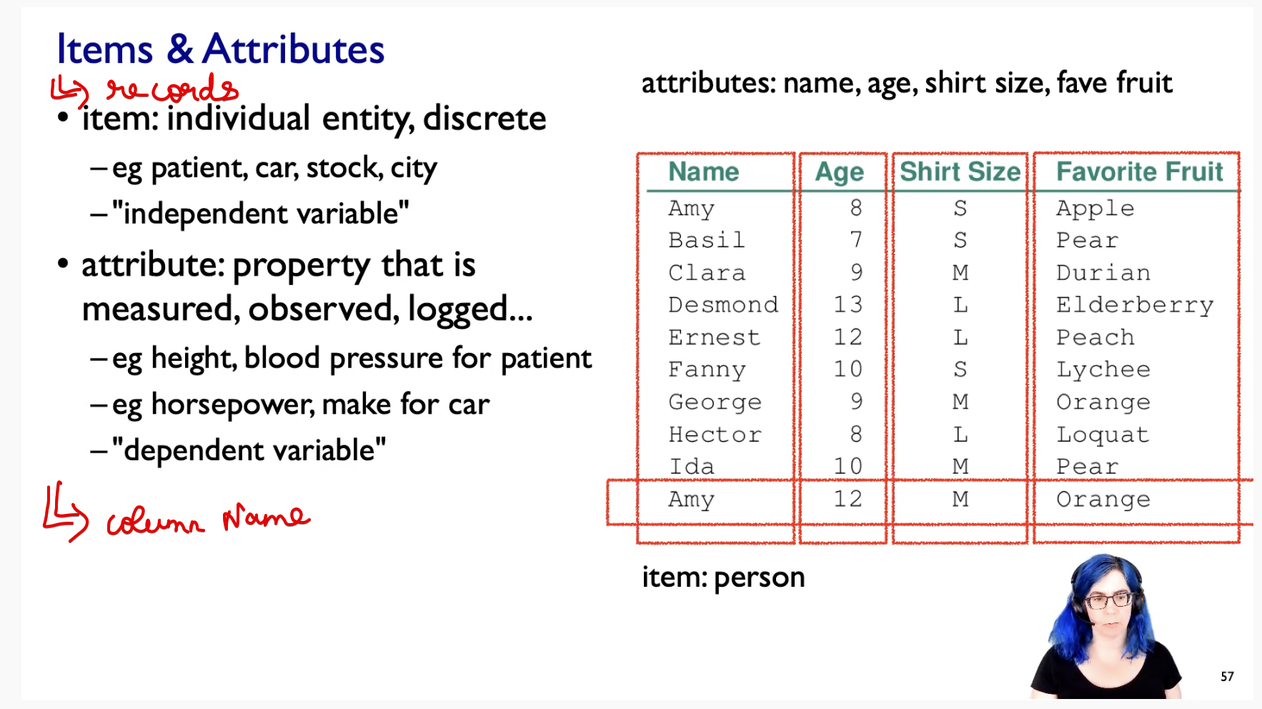

## **Data Types**

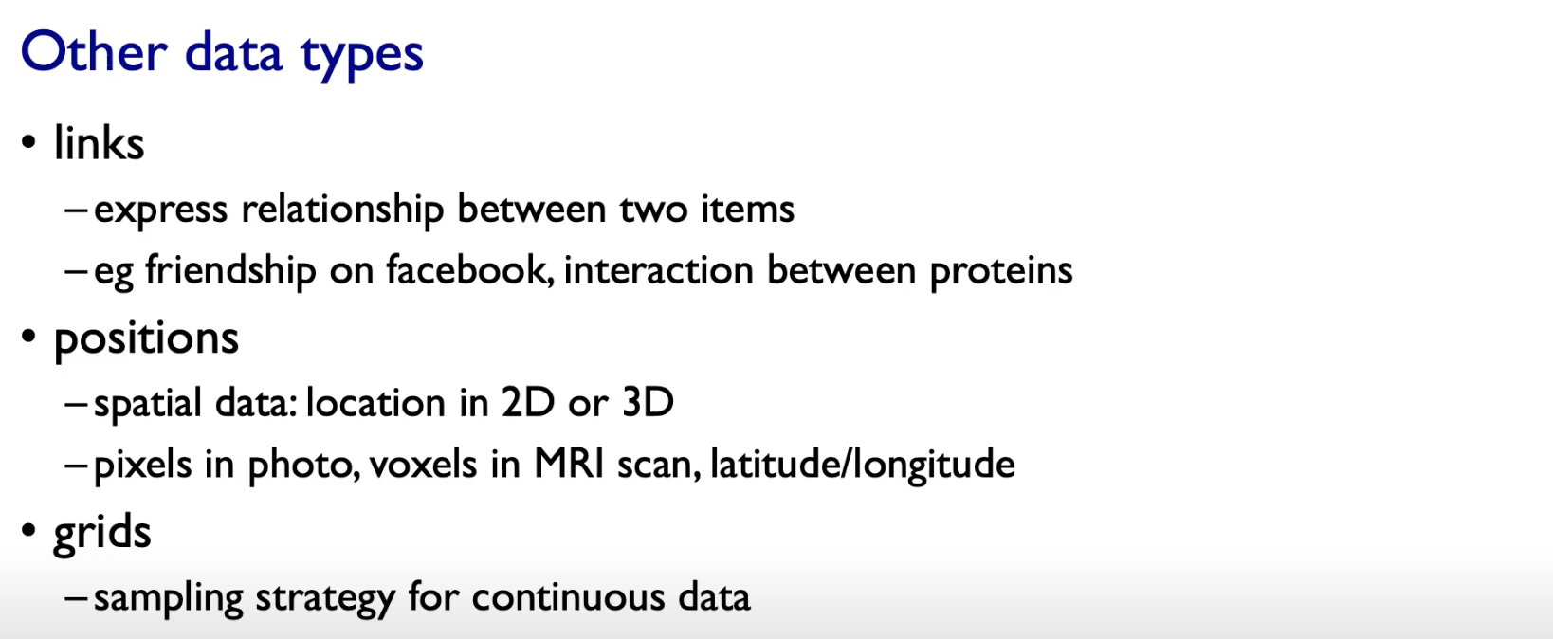

## **Data-set Types**

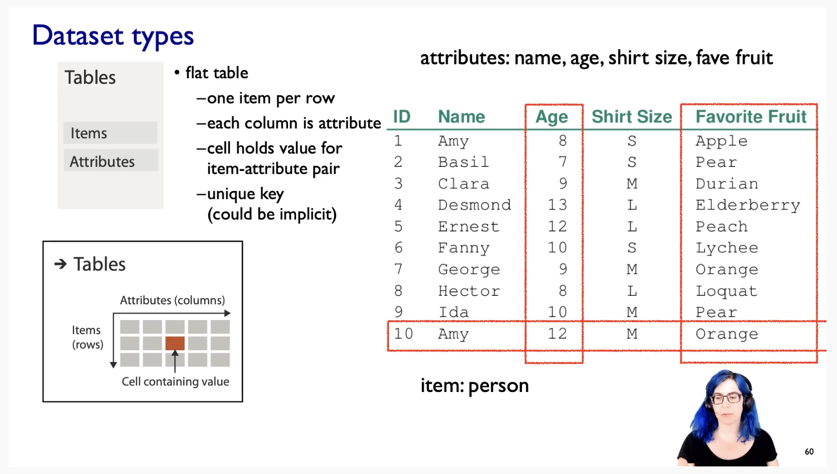

### **Tabular**

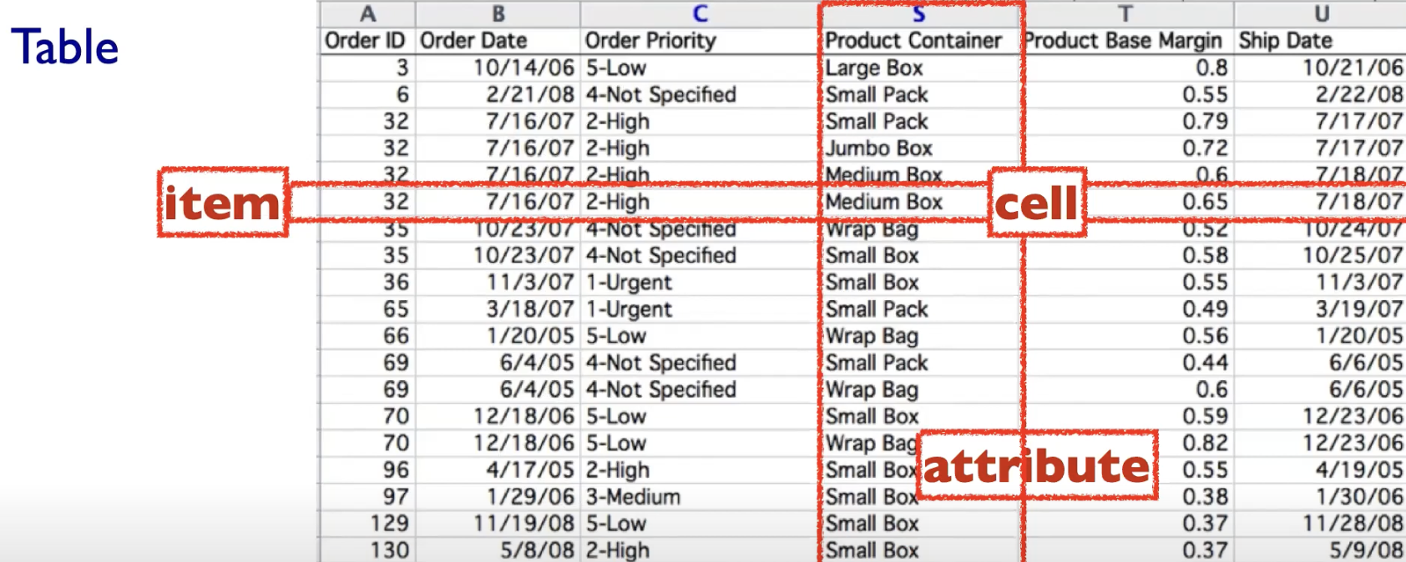

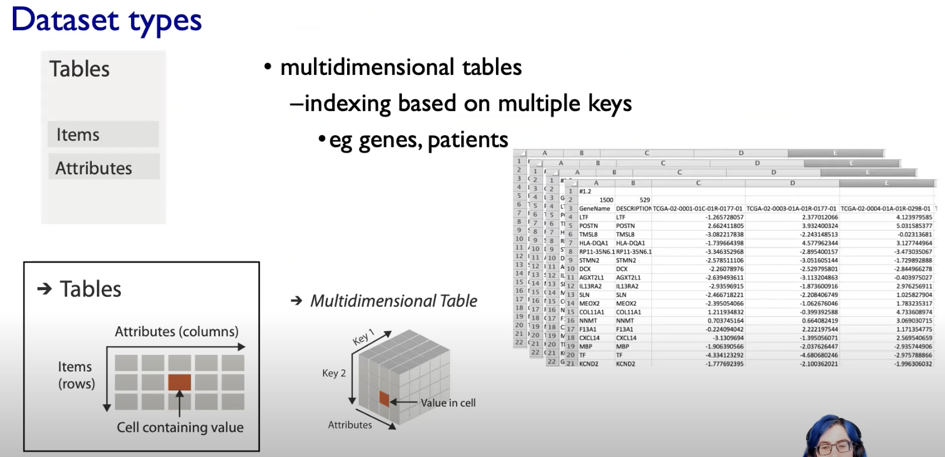

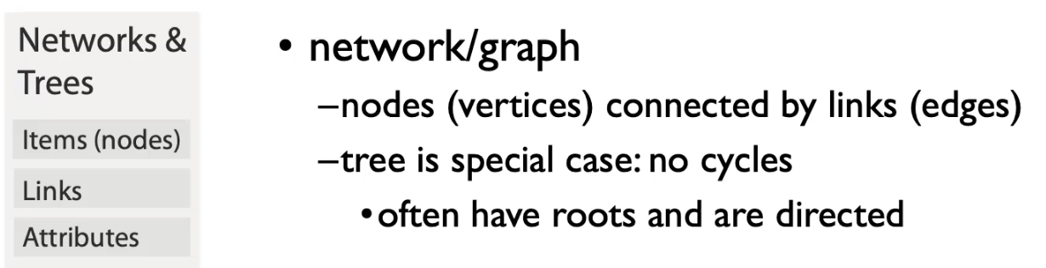

In Network context, the attributes could be either be attached   
to the nodes or the links or both.

So we can distinguish between Node-attribute and Link-attribute with the network data-sets.

### **Spatial Fields**

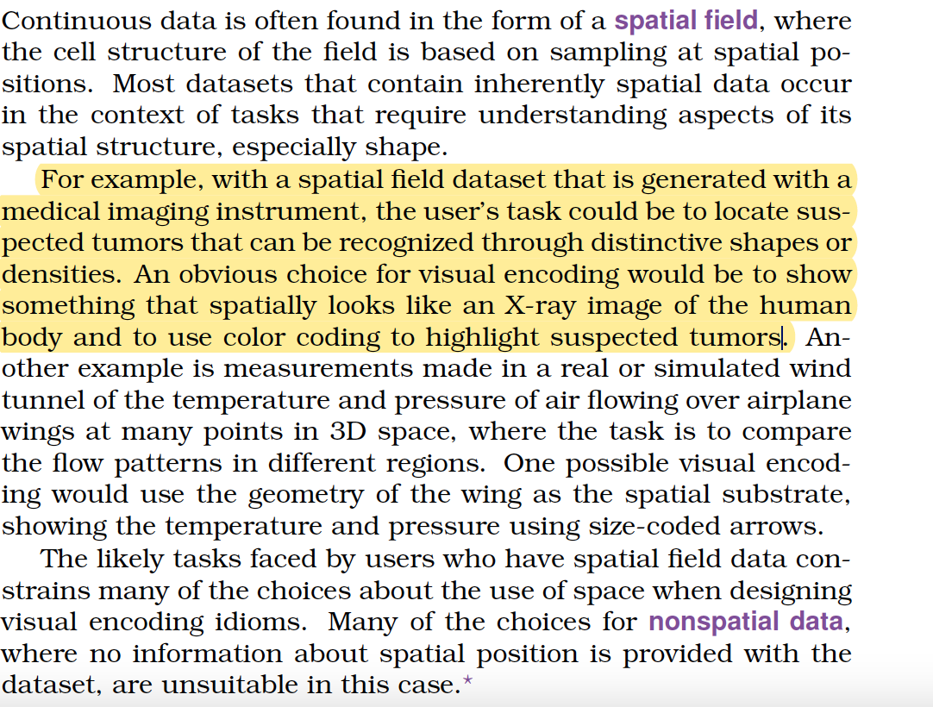

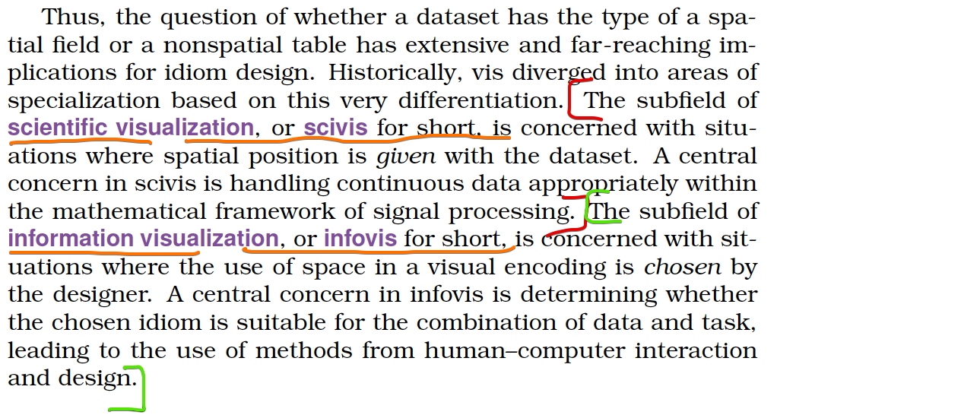

Here the attributes are tied upon a specific spatial locations or regions

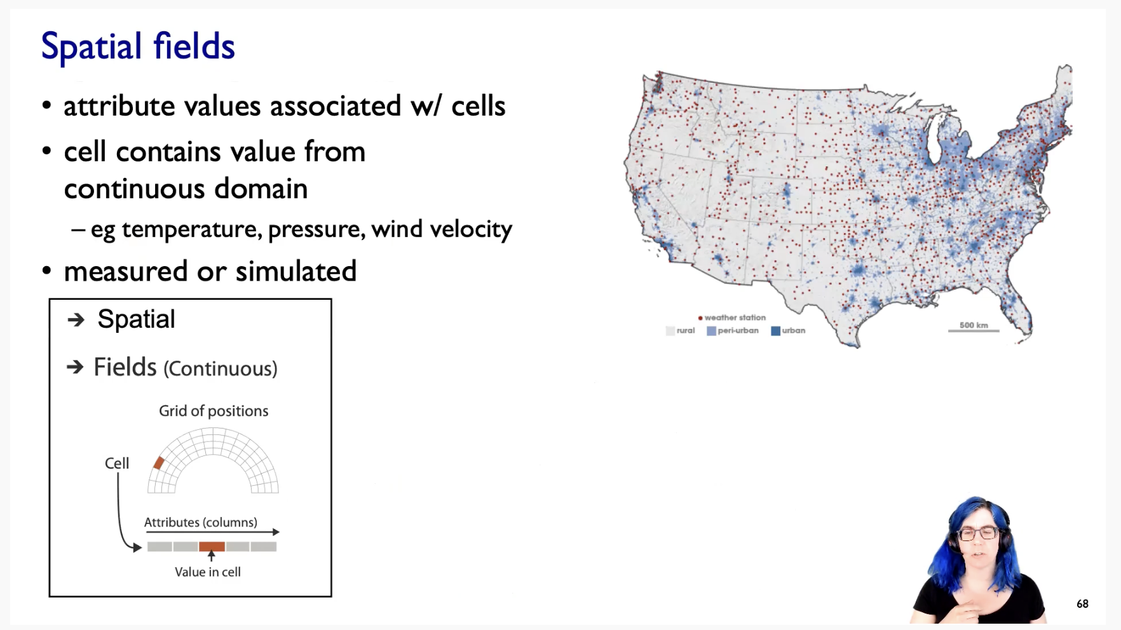

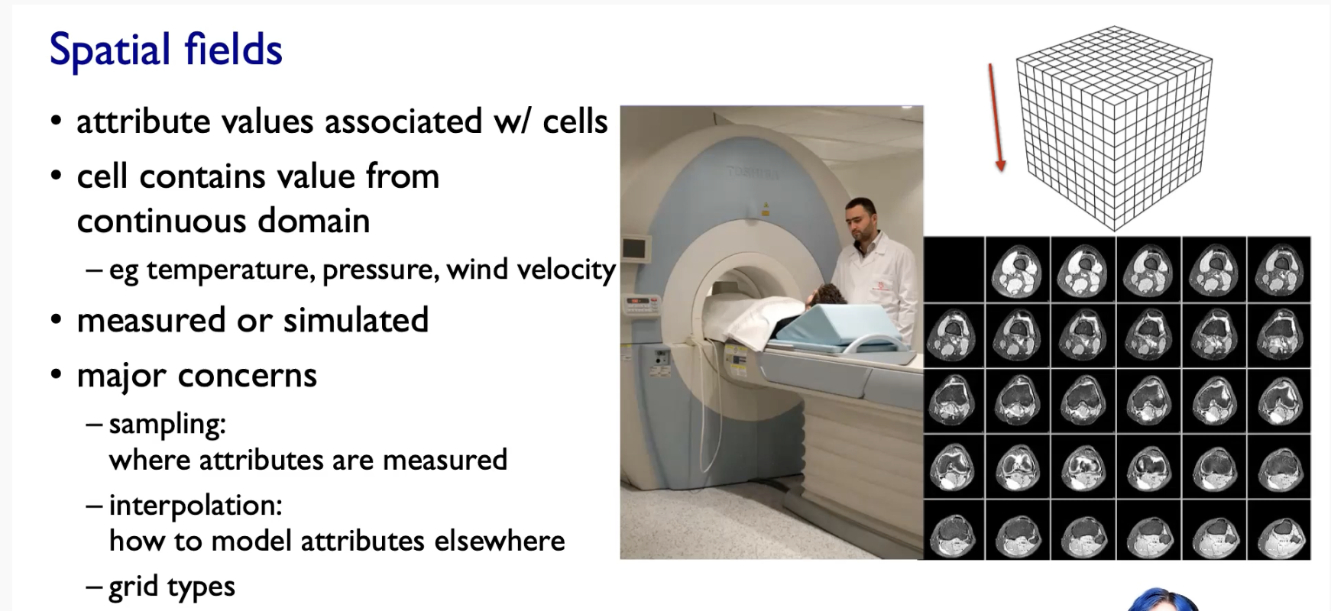

The major concern with the sort of continuous spatial field data collection is about sampling and interpolation.

Sampling 🡪 Where we are measuring these attributes ??  
Interpolation 🡪 How you would impute a value between sample points ??

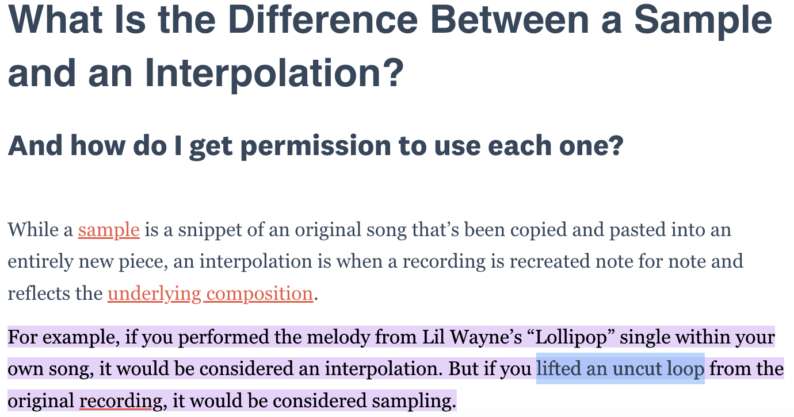  
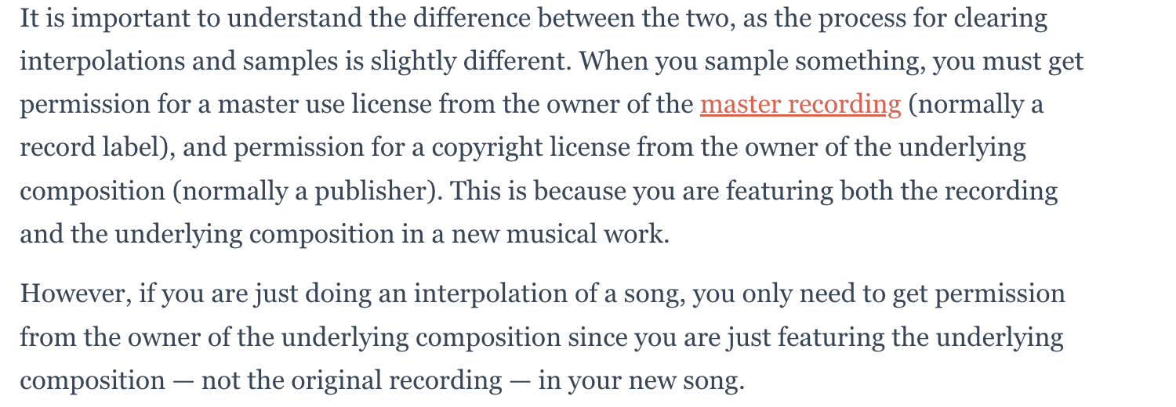

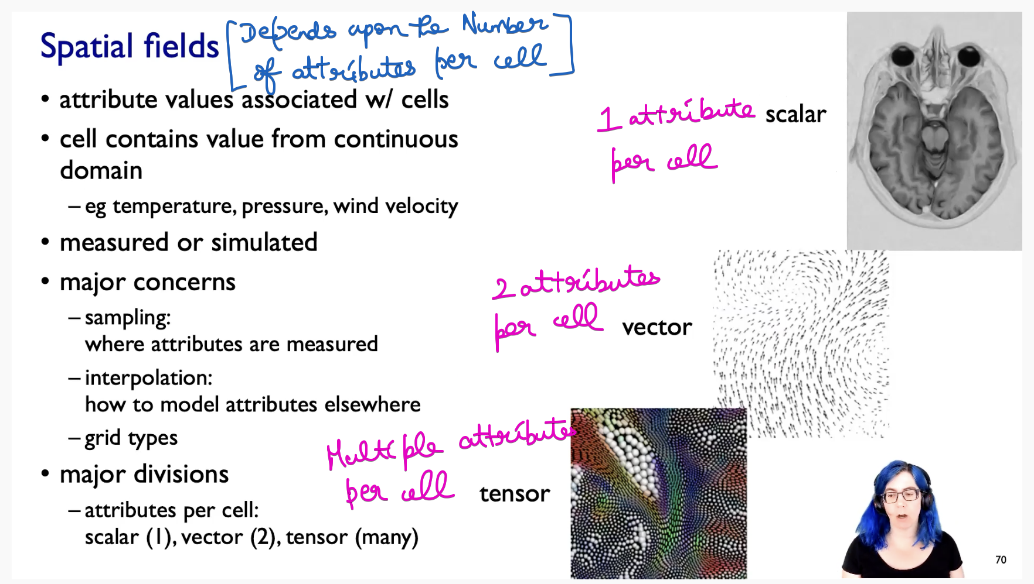

### **Geometry**

What is the boundary between computer graphics and visualization ??

In Computer graphics 🡪 The geometry you take as given. It is given to you, and then you have the problem of how to actually render the geometric information according to some sort of synthetic idea of where the cameras and light are .

In Visualization 🡪 We do worry about drawing that picture, which is equivalent to rendering graphics, but the key point is that the geometry is the result of a design decision by the visualization designer.

### **Collections**

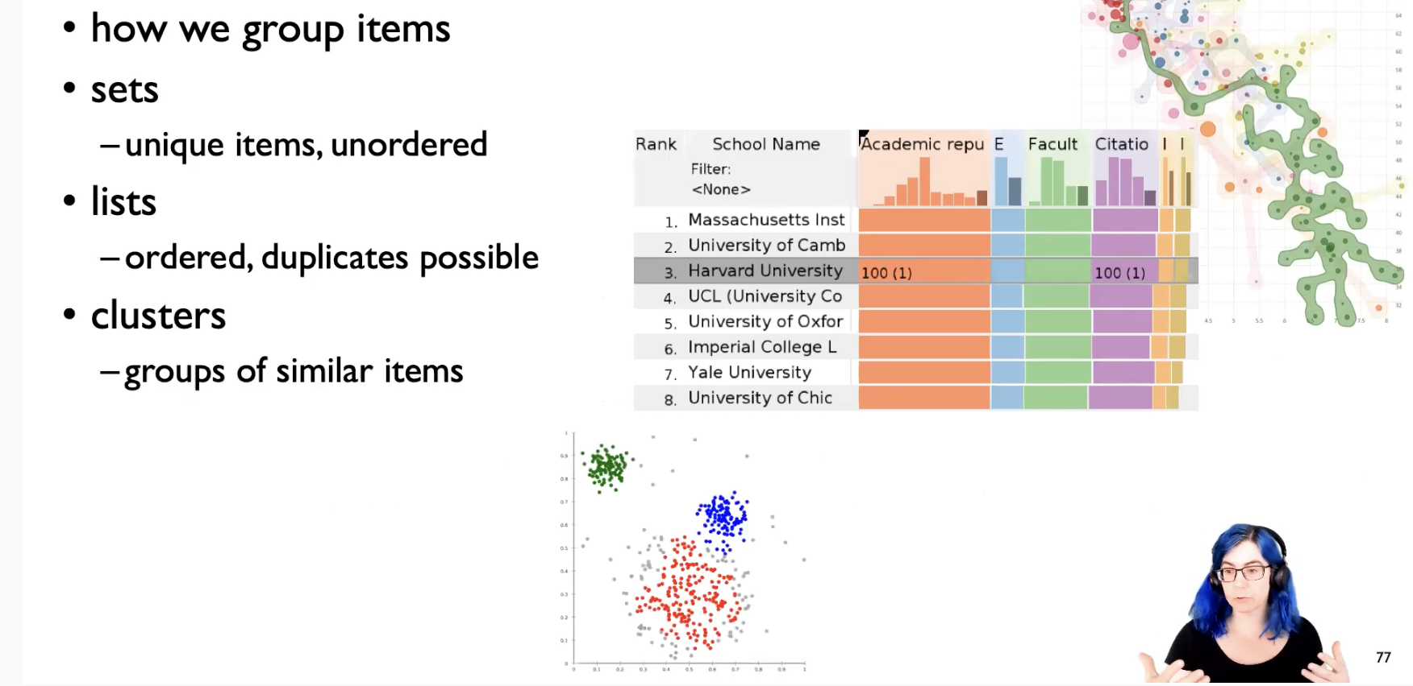

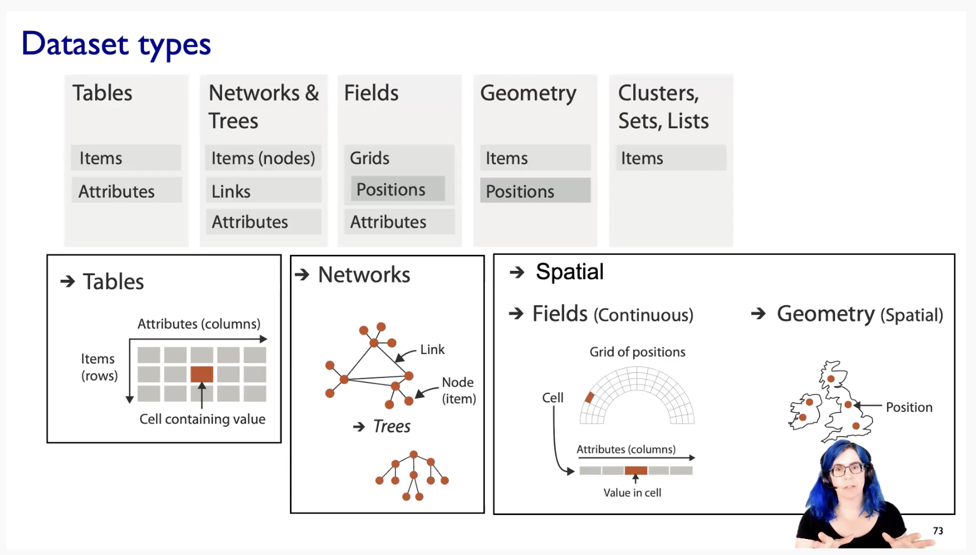

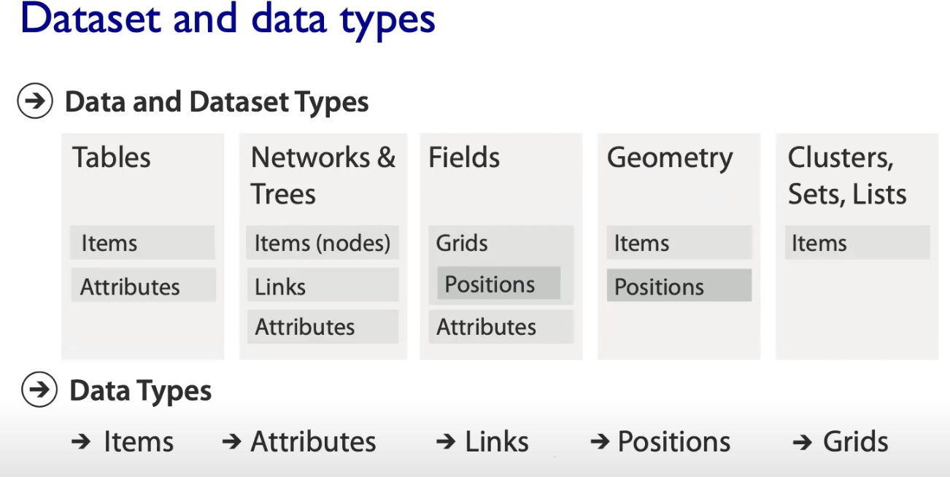

## **Attributes Types**

**Nominal data** is classified without a natural order or rank, whereas **ordinal data** has a predetermined or natural order.   
On the other hand, **numerical or quantitative data** will always be a number that can be measured.

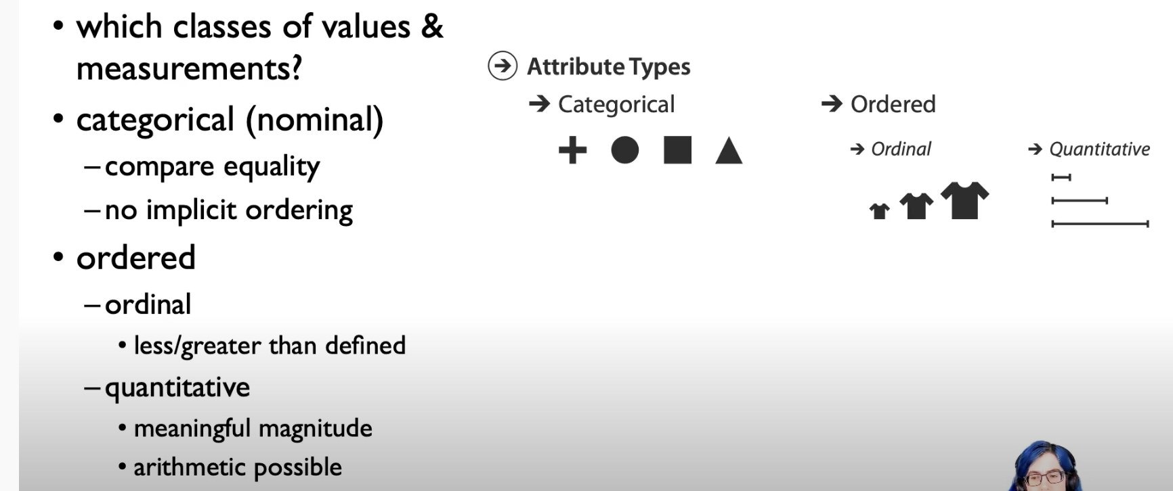

Ordinal Data 🡪 We can say medium t-shirt is between small and large t-shirts.   
But we cannot able to calculate Large t-shirt minus Small t-shirt.   
[No possible for doing any arithmetics]

Quantitative Data 🡪 We can do some arithmetic operations

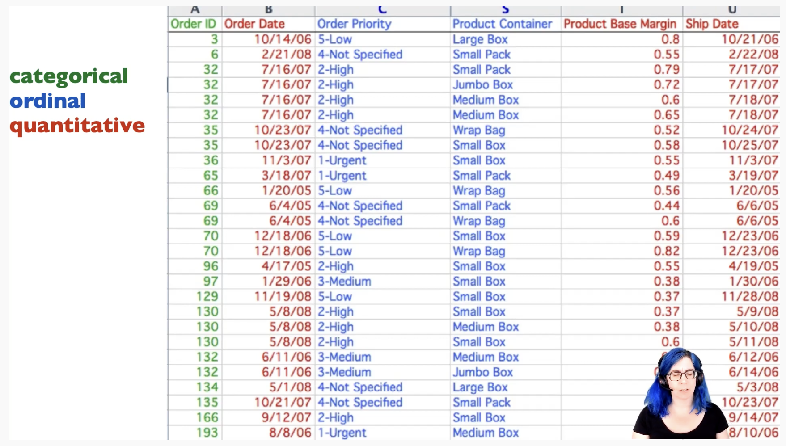

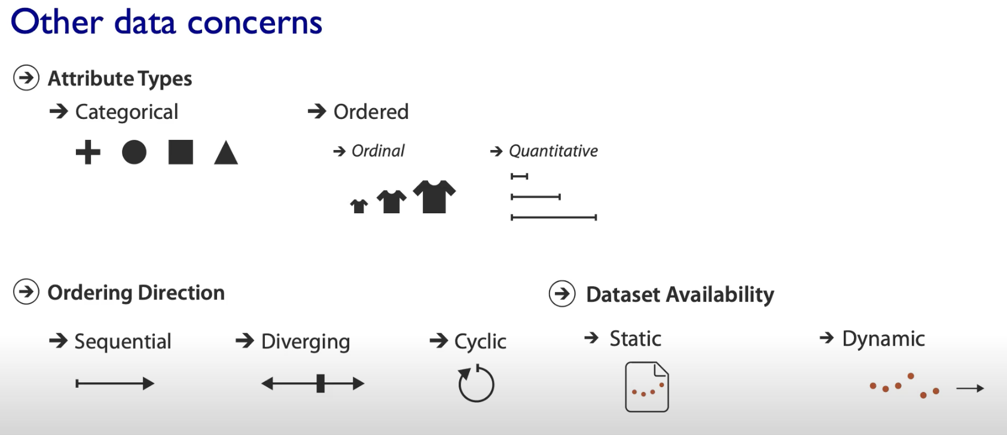

Sequential 🡪 From min to max (or) From max to min  
Diverging 🡪 left | threshold-point | right  
Cyclic 🡪 seasonal data (Repeats over a time)

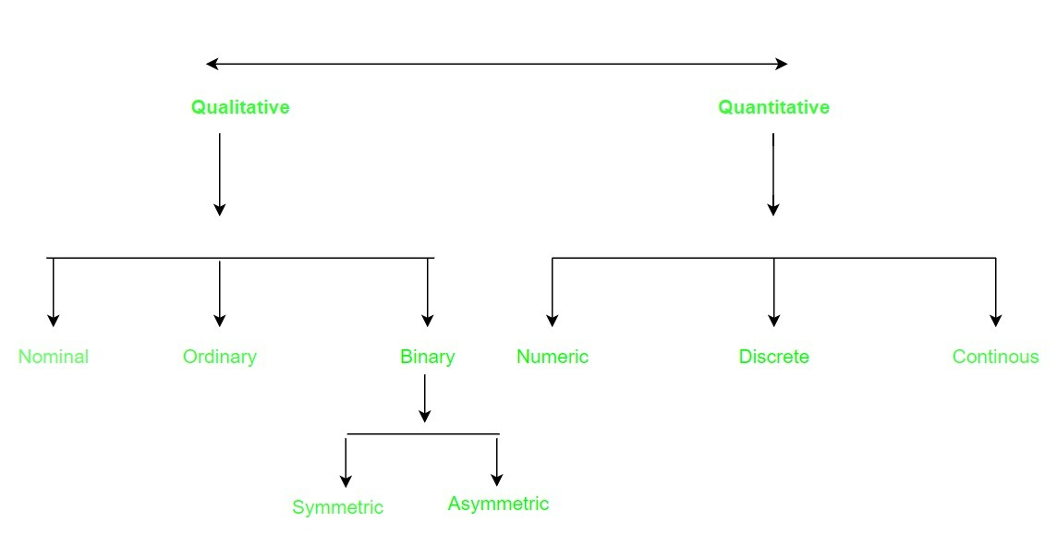

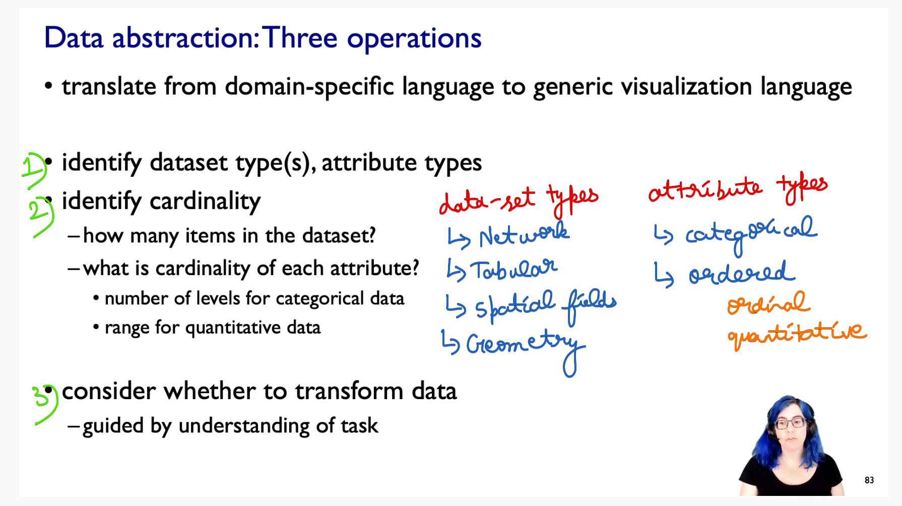

3) 🡪Do I need to transform the data ???  
Can I take the data it as given ??   
(or) Do I need to transform it to some other kind of data ???

This consideration must be guided by under-standing the task.  
This is why the task and data are tied together in-terms of abstraction level.

What is meant by transforming the data ???

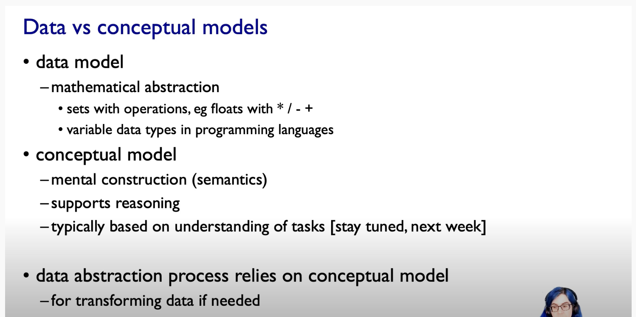

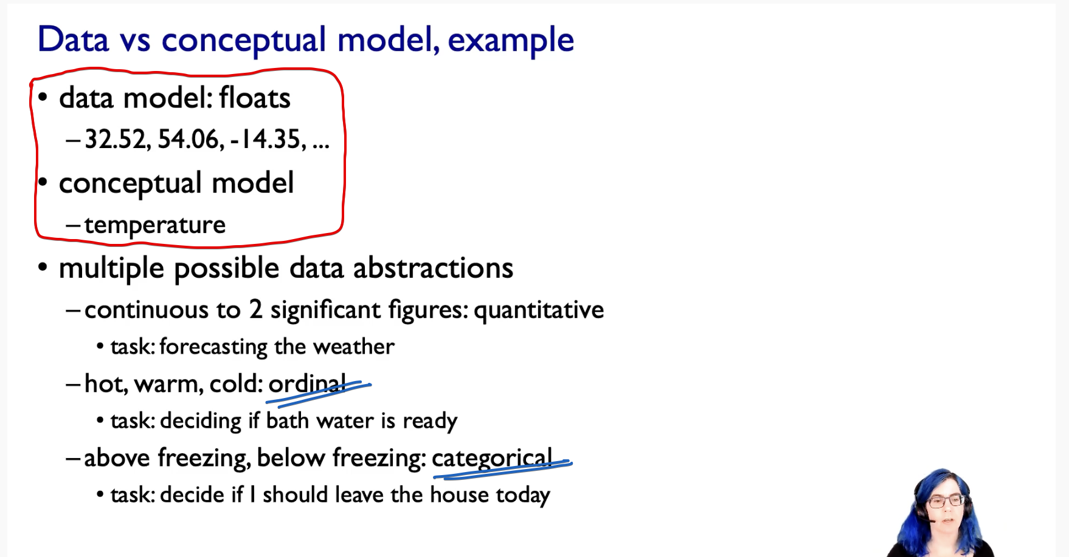

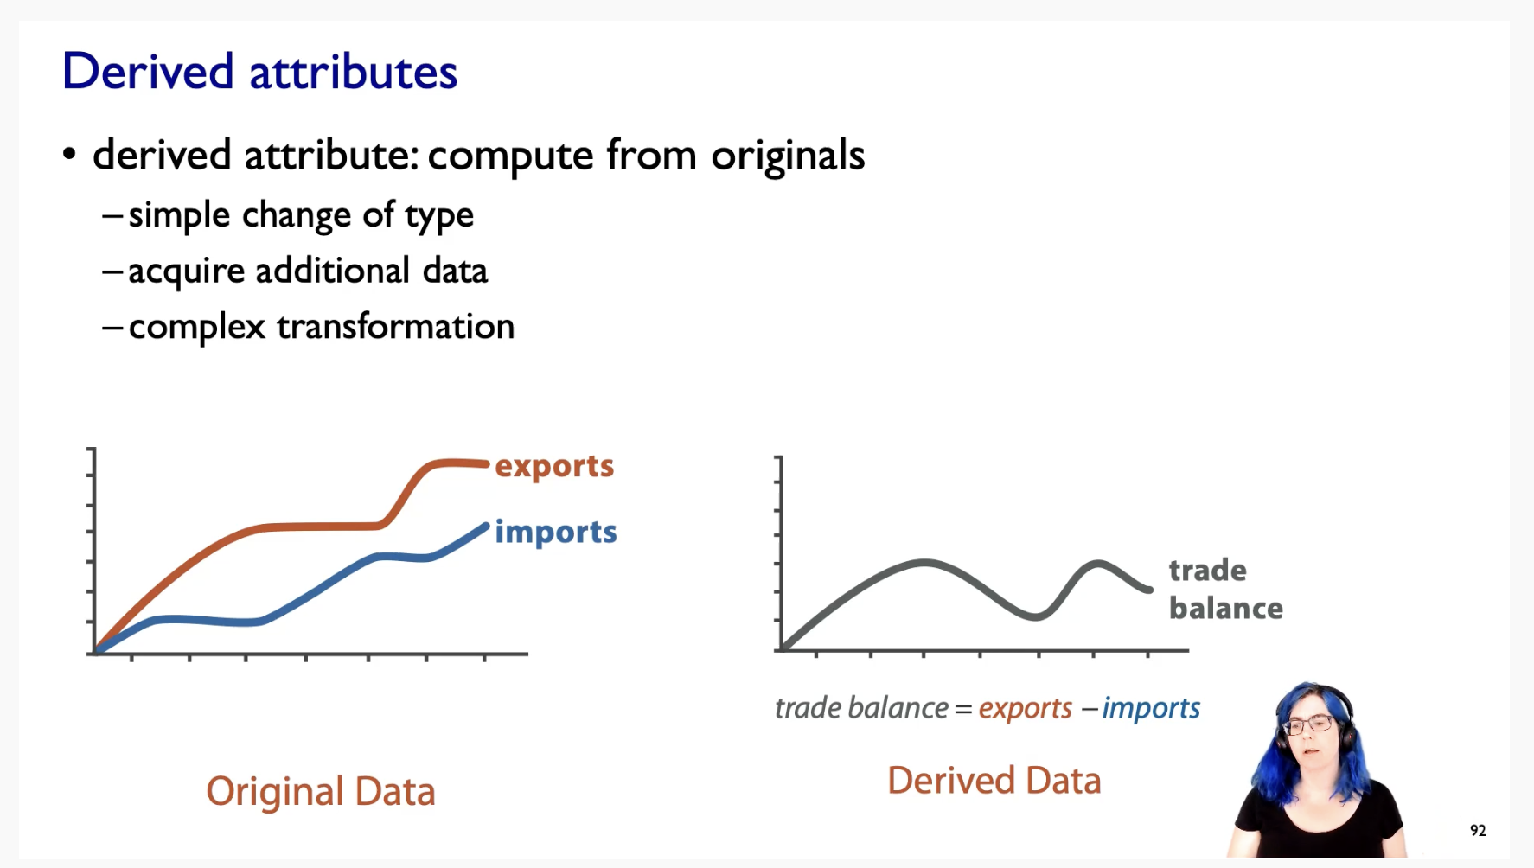

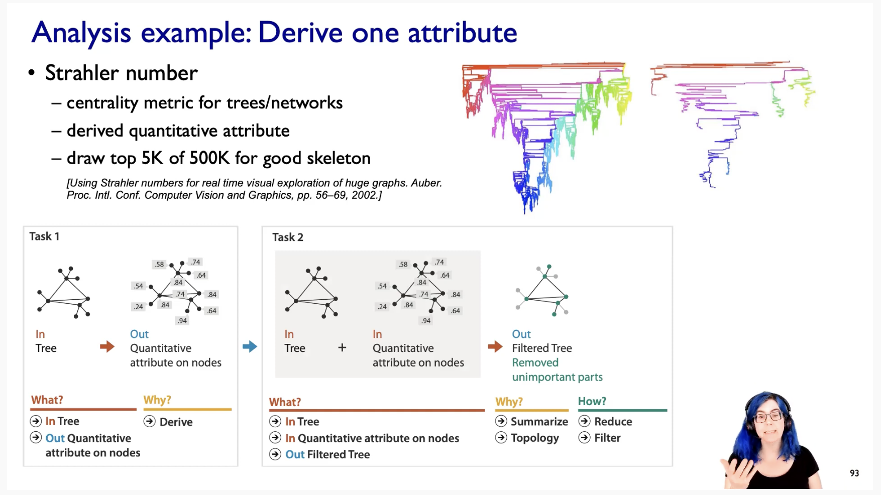

# **Task Abstraction**

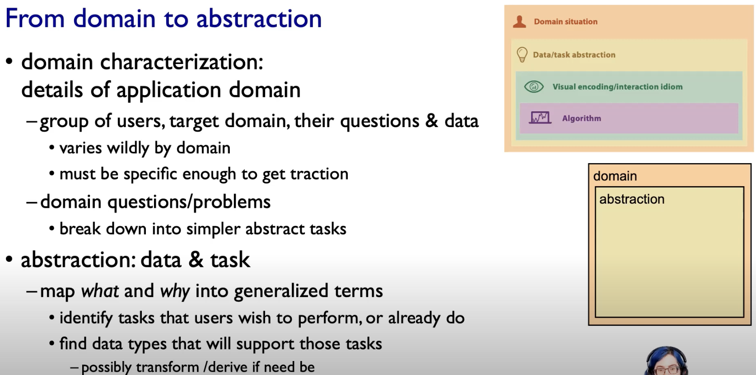

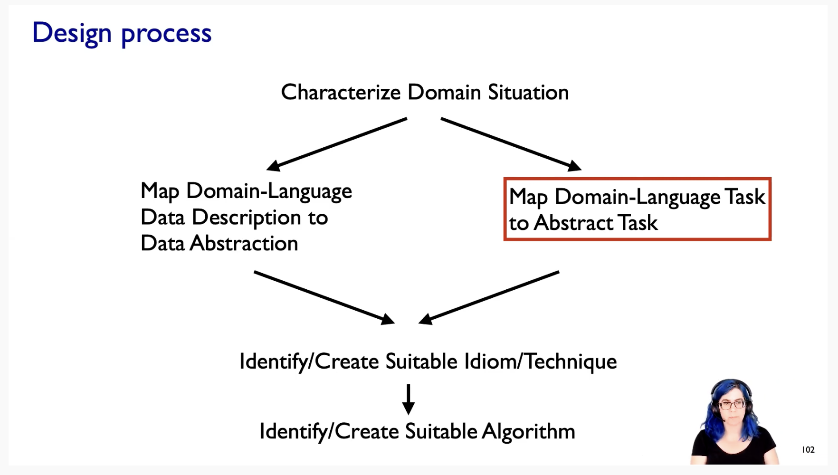

## **Actions : Analyze**

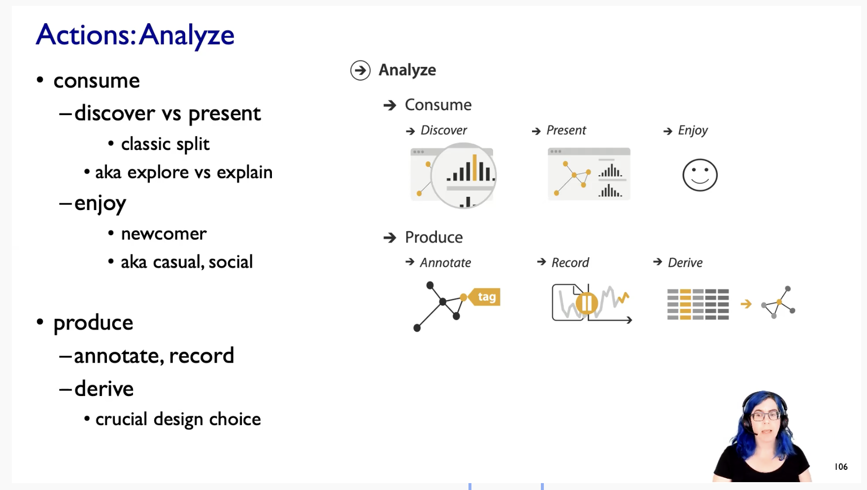

## **Actions : Search**

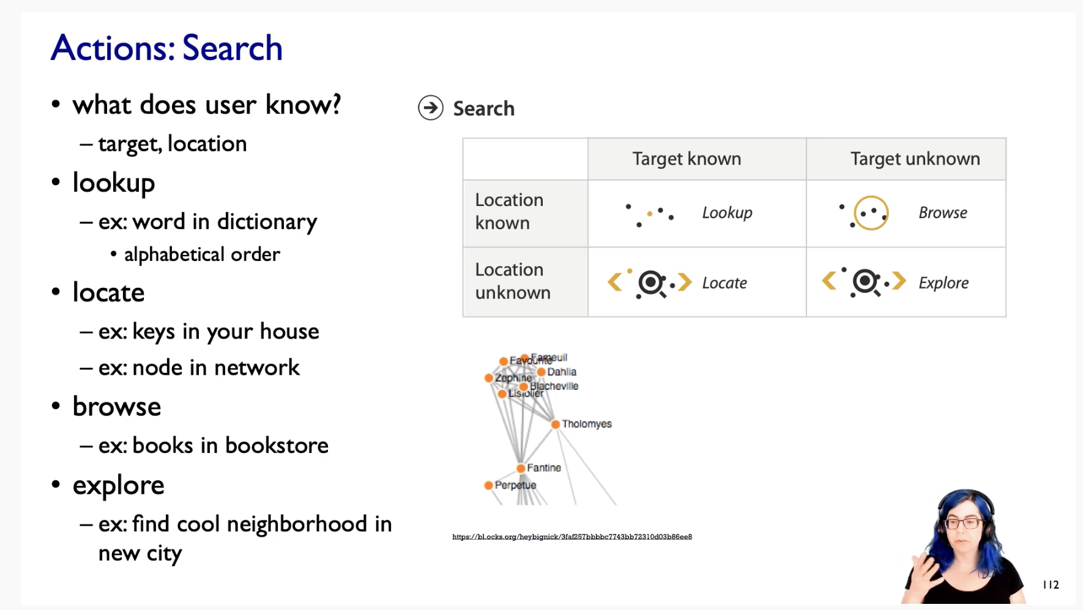

## **Actions : Query**

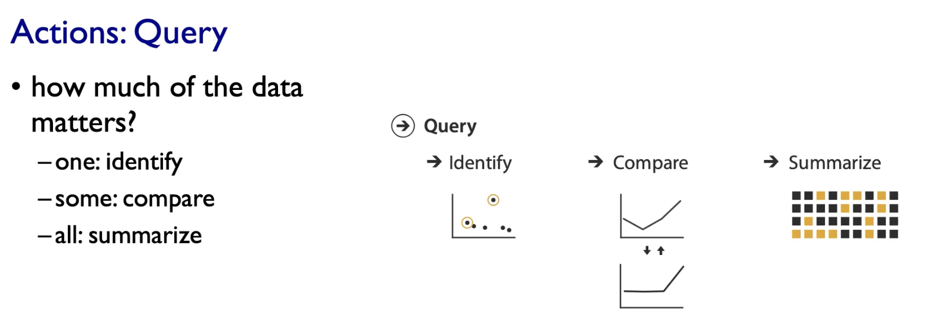

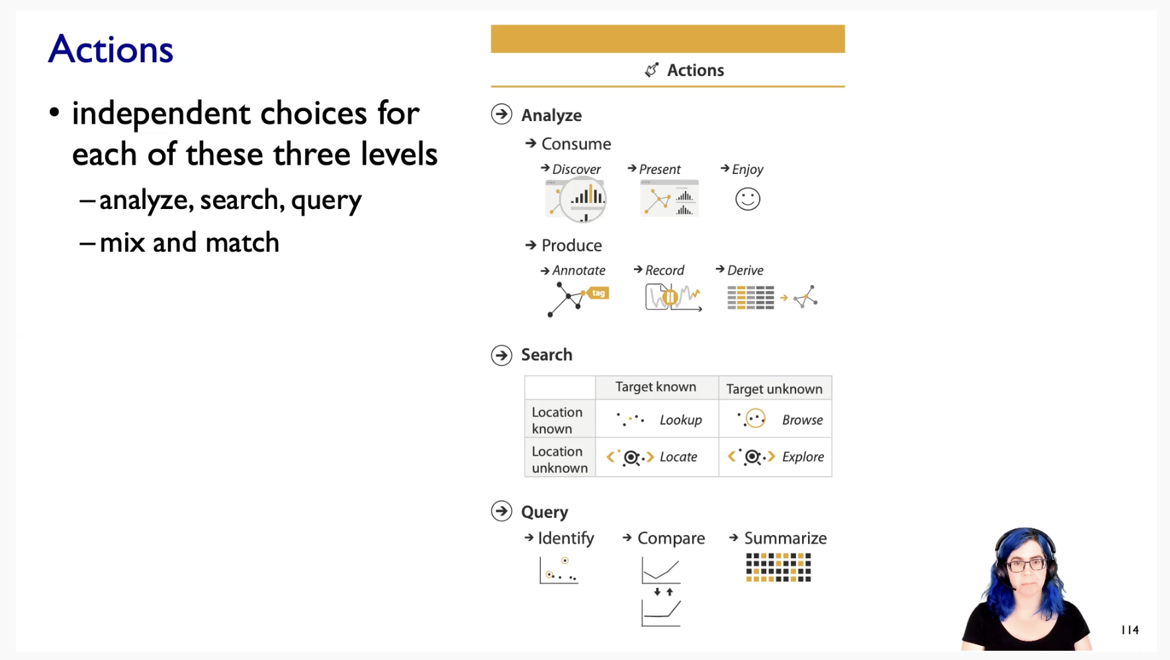

Analyse, Search and Query are completely in-dependent of each-other.

## **Target**

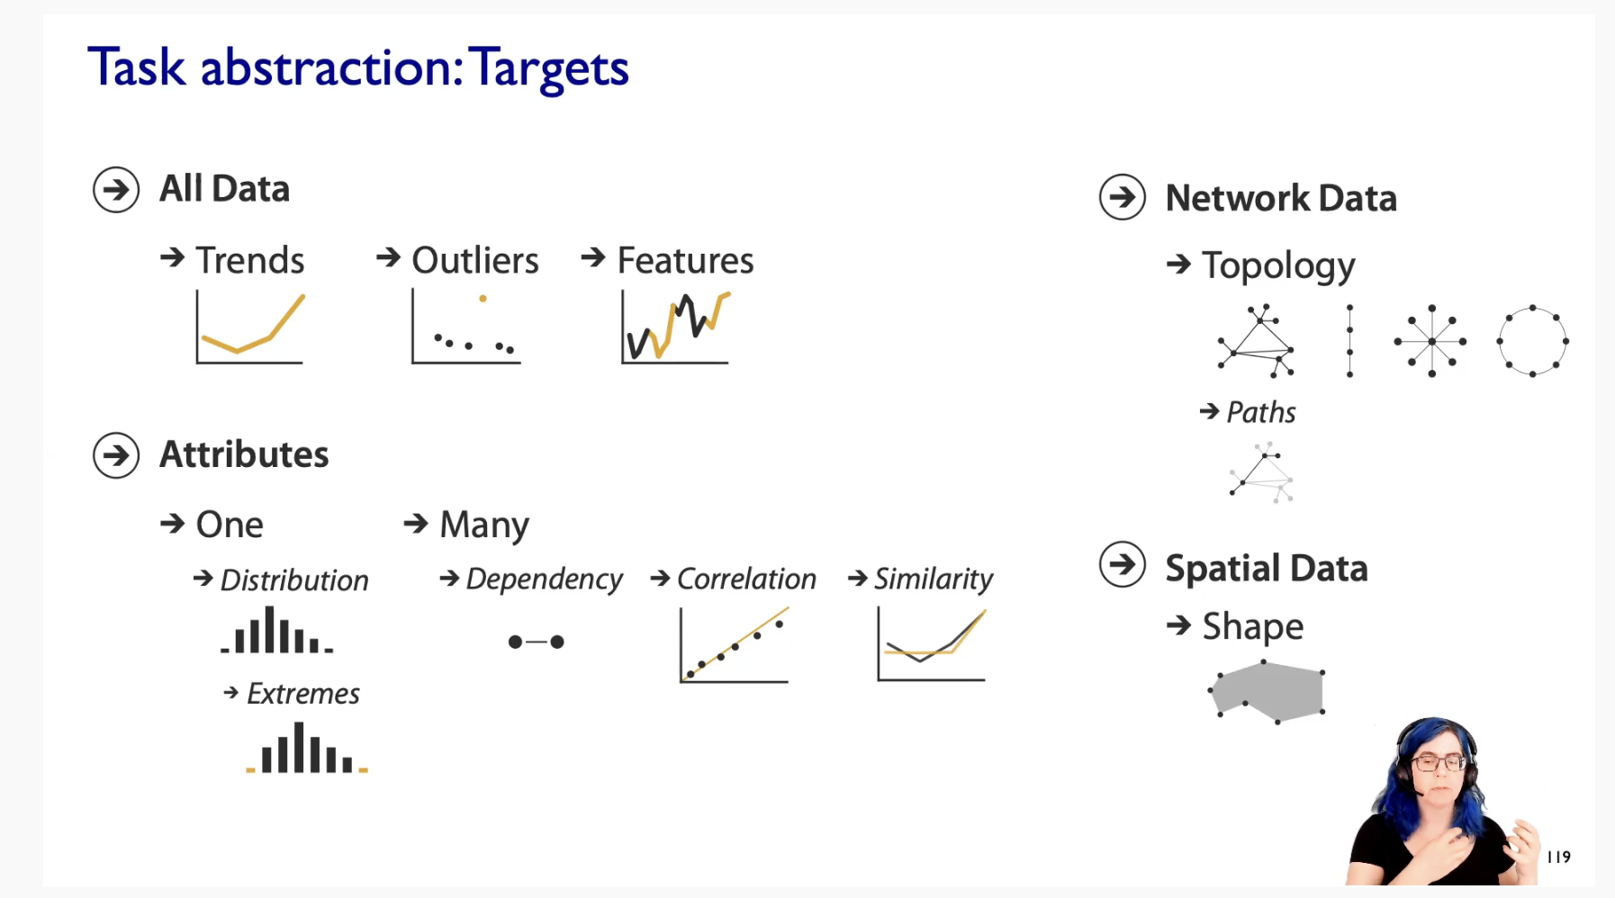

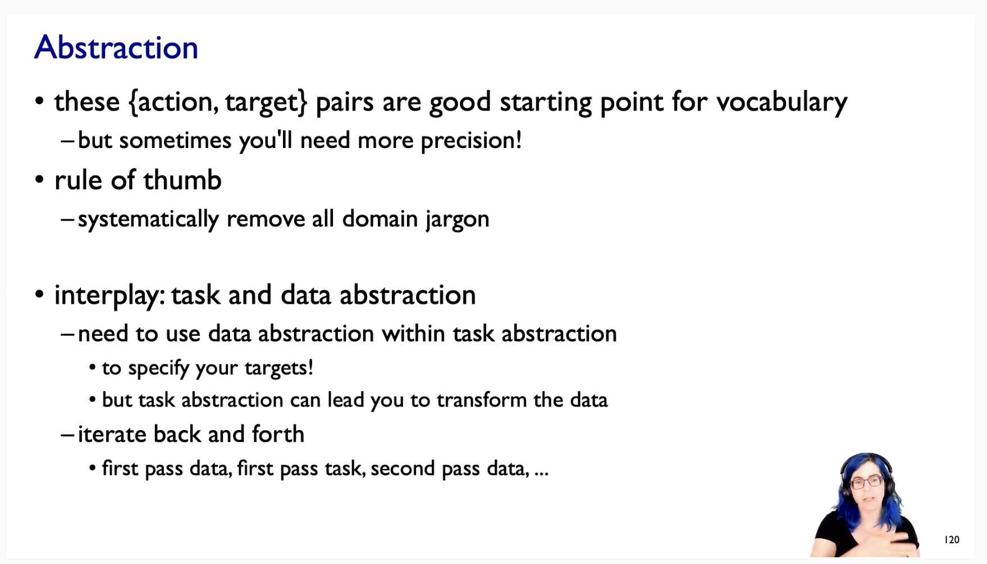

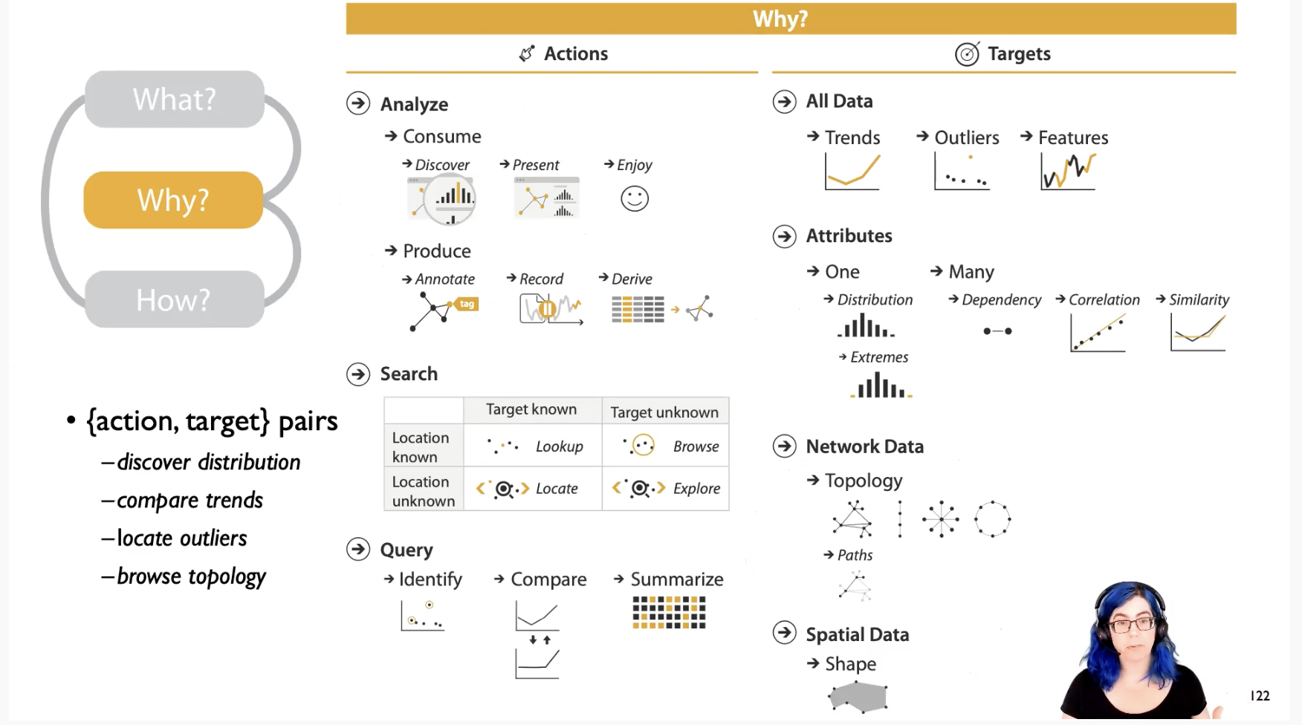

# Exercise

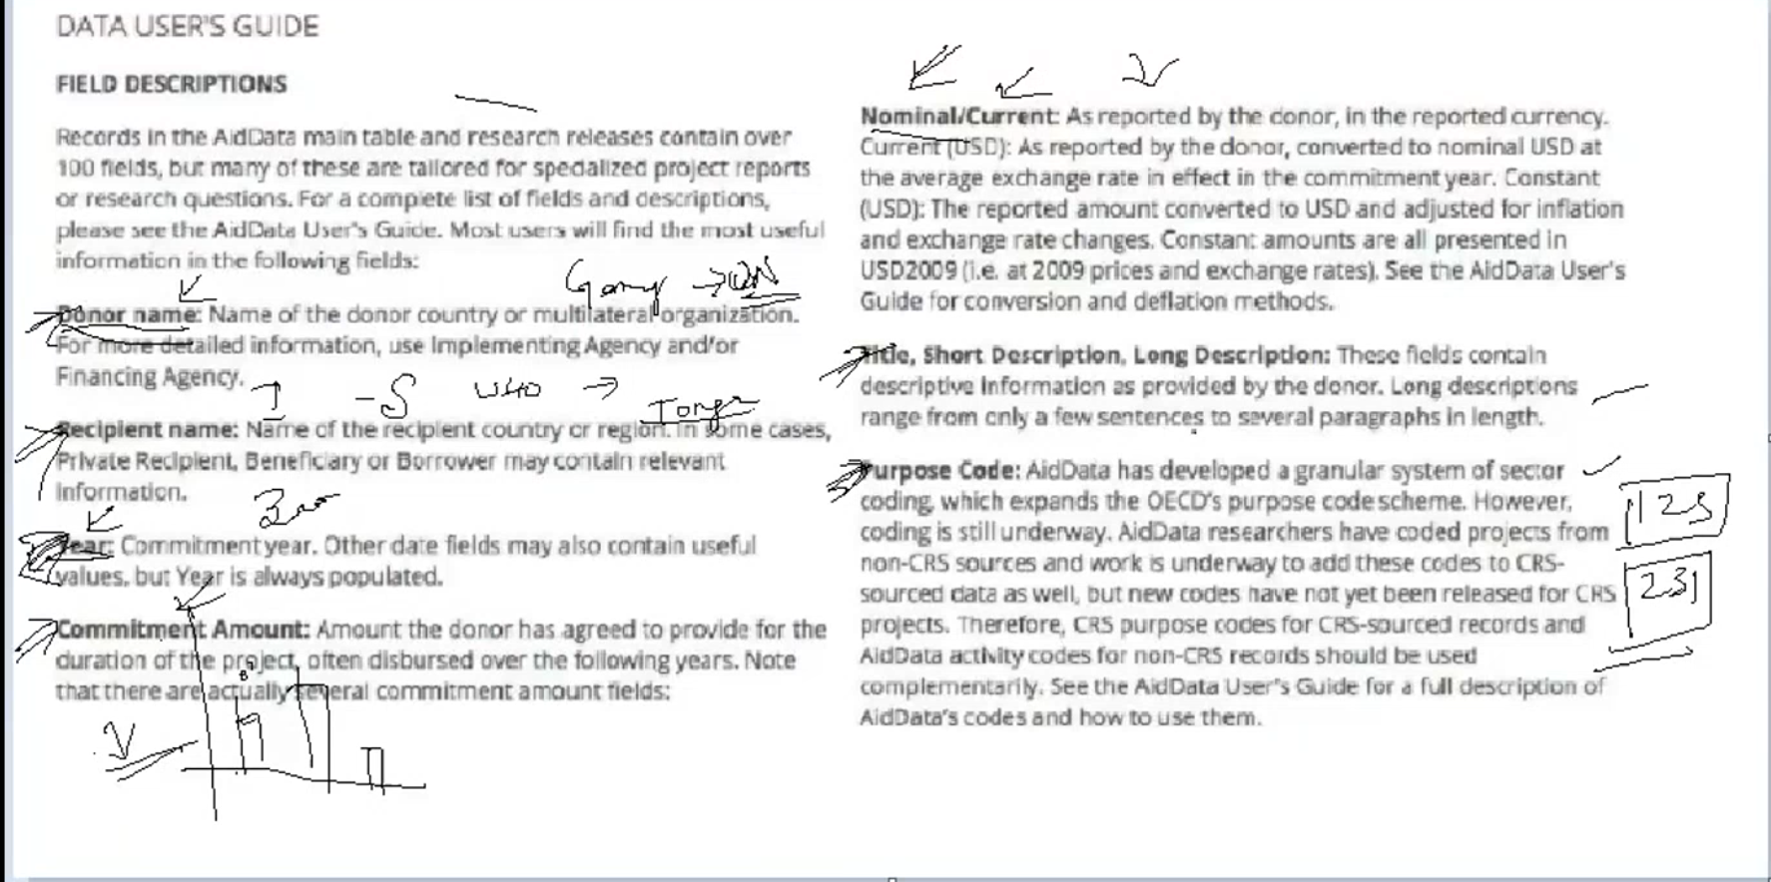

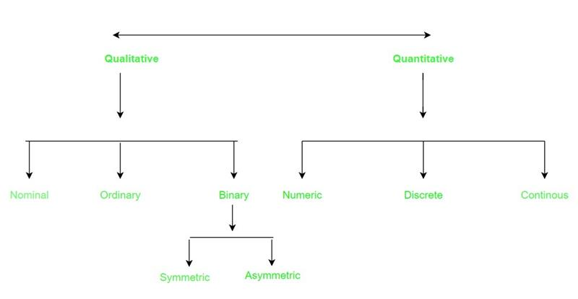

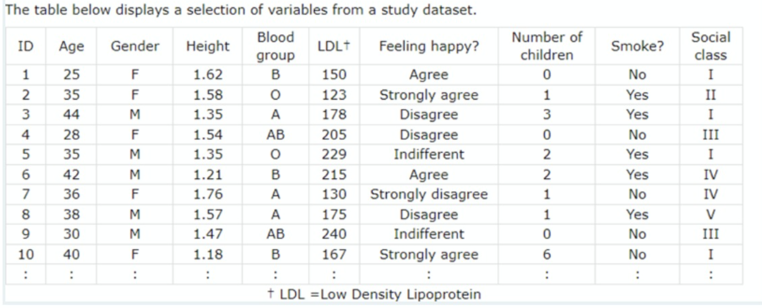

Quantitative variables 🡪 Age, Height, LDL+, Number of children  
Qualitative variables 🡪 Gender, Blood Group, Felling happy?, Smoke?, Social class  
Continuous variable 🡪 Age, Height, LDL+  
Discrete variables 🡪 Number of children ?

Ordinal attributes 🡪 Social class, Felling happy?  
Nominal attributes 🡪Gender, Blood Group, Smoke?  
Binary attributes 🡪 Gender, Smoke?